Postman Work Flow (3 steps)

1. Log in

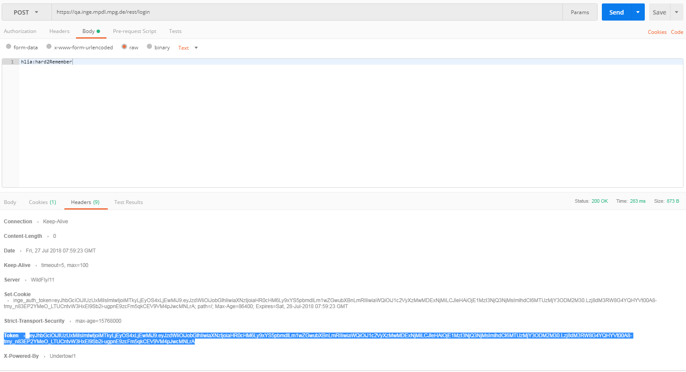

Keep the *Token* for further usage

1. Uploading Files (full pdf text)
   1. In Header, Key: *Authorization*, Value: your Token

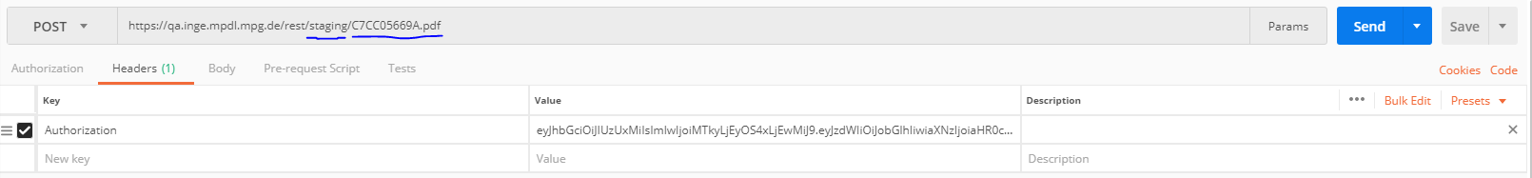

* 1. In body, choose *binary*, upload the pdf file

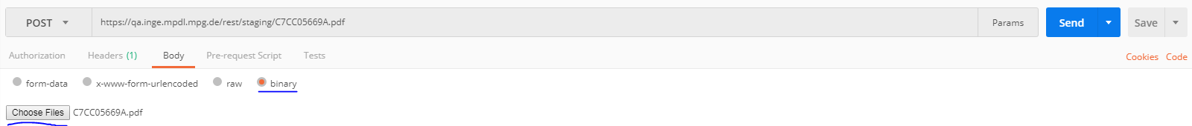

* 1. Get the file ID from the Body of the received message, but might get a pdf file which contains the ID to download.

1. Items (JSON meta data)
   1. In Header, Key: Authorization, Value: your Token

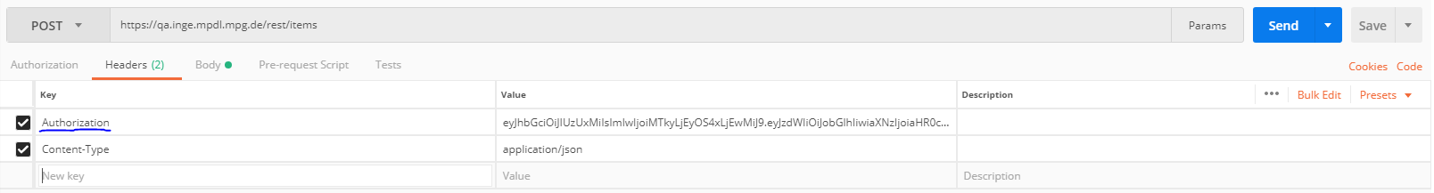

* 1. In body, choose *raw*, *JSON*, copy the json text into the body; send.

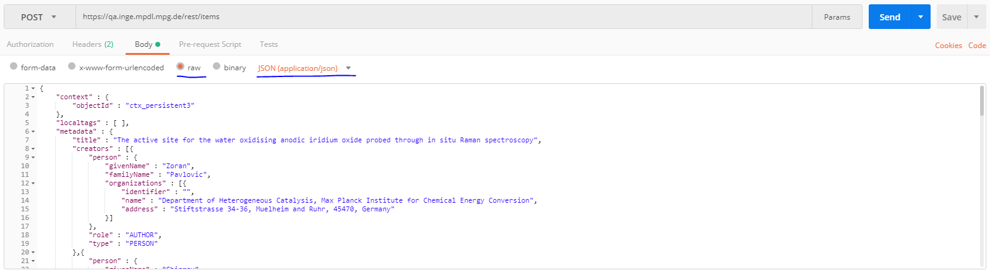

* 1. Body of the returned message should be json context containing the metadata and extra uploading data.

1. Check *My Items* on <https://qa.inge.mpdl.mpg.de/pubman/faces/DepositorWSPage.jsp>